How to create an HTTPD Pod in Elastic Kubernetes Service (EKS) with 4 replicas and browse that in Google.

First, create an Elastic Kubernetes Service (EKS) on AWS.

We already set Kubernetes up in our local machine so we directly go to the PowerShell terminal

And create an Elastic Kubernetes Cluster.

Command: - eksctl create cluster --name testctl --nodegroup-name testctlng --node-type t2.micro --nodes 4 --managed

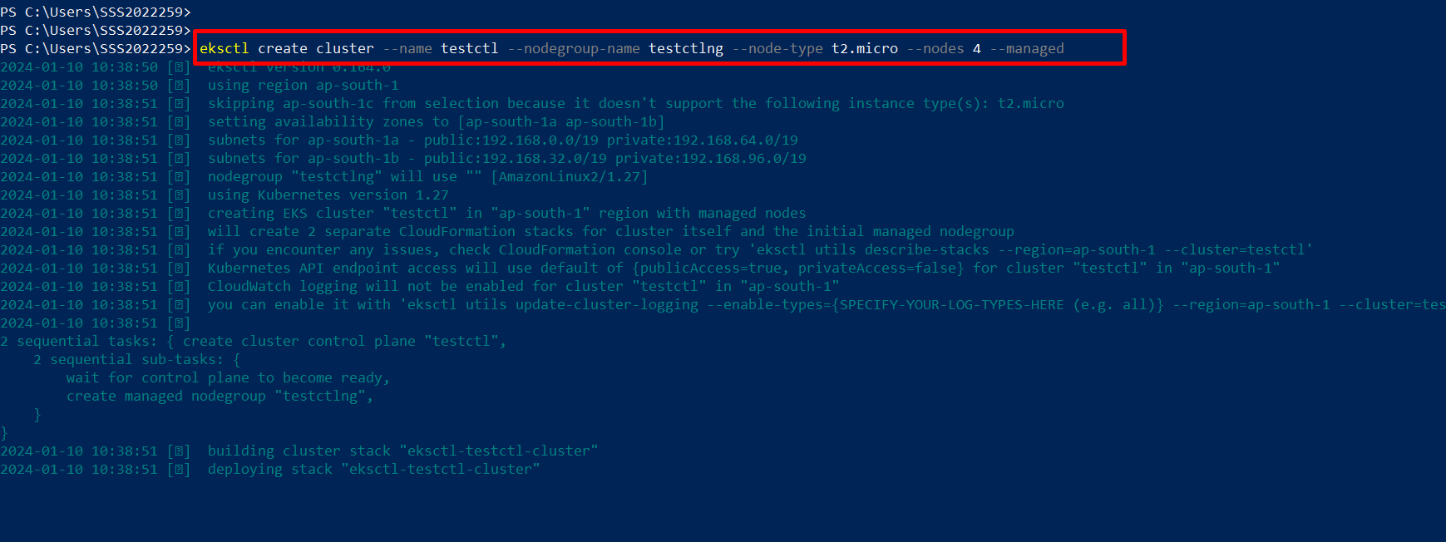

It takes more than 10 mins to create, wait for that.

We successfully created the EKS cluster.

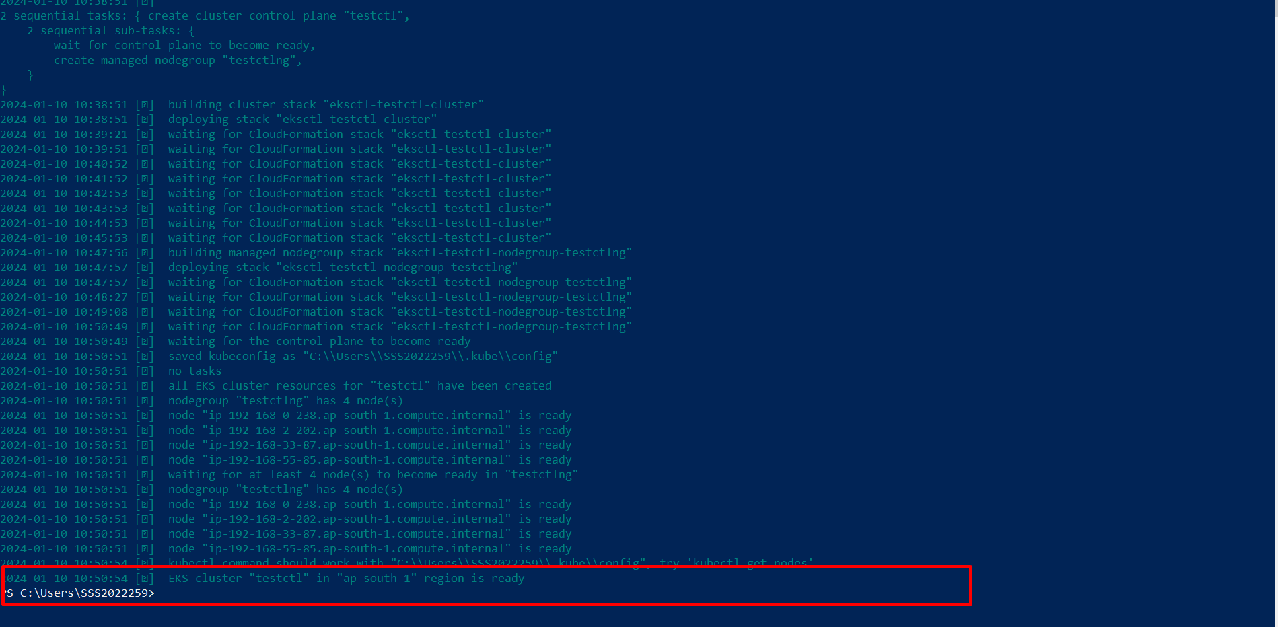

Now we check cluster details.

Command: - eksctl get cluster

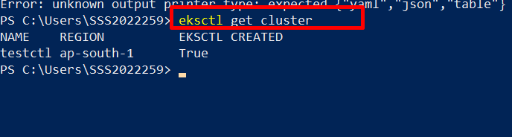

Now we create a deployment.yaml file for creating httpd pod with 2 replicas

I created Httpd-deployment.yaml file on my local machine.

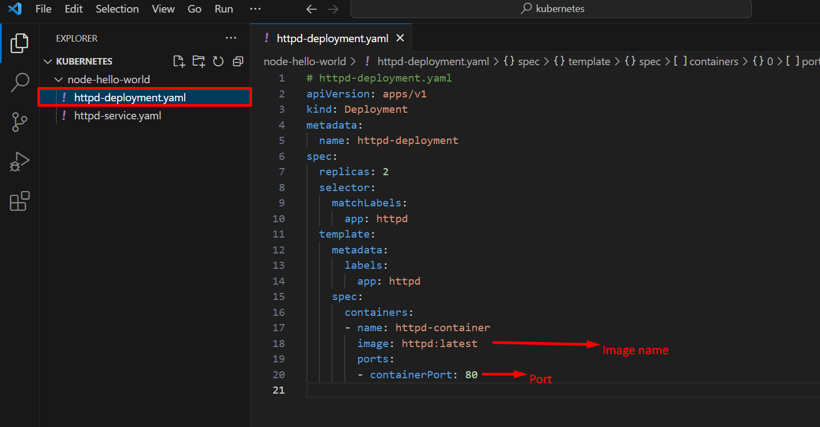

Replicas: 2 means, create 2 pod

Replicas is used for, incase unfortunately 1 pod is deleted, on that time automatically create another pod as same configurations.

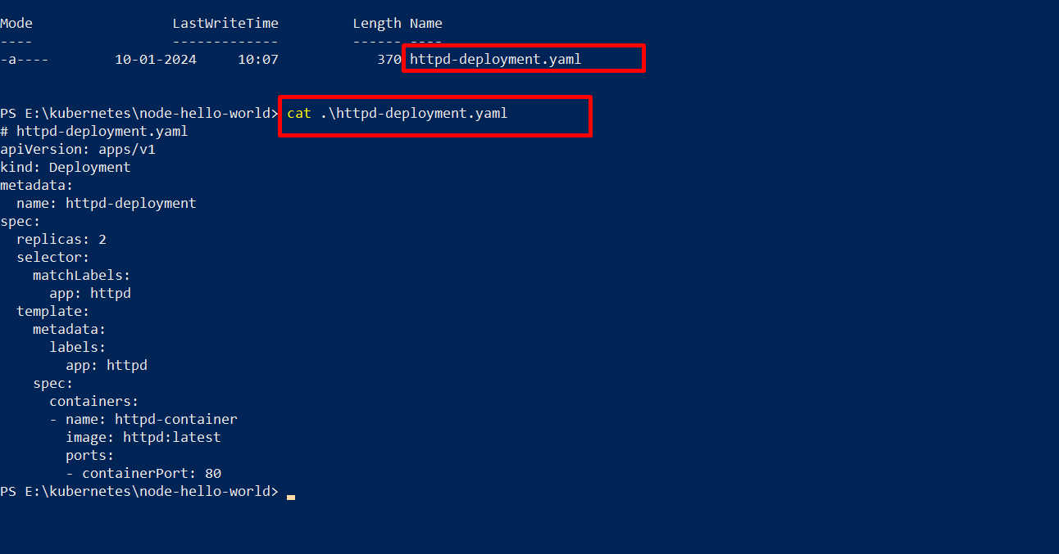

Here we create httpd-deployment. Yaml file, now we apply that file.

Command: - kubectl apply -f httpd-deployment.yaml

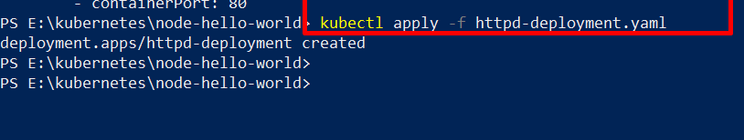

Here successfully created two pods.

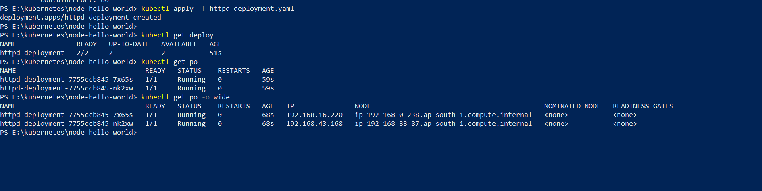

Now we create service.yaml file.

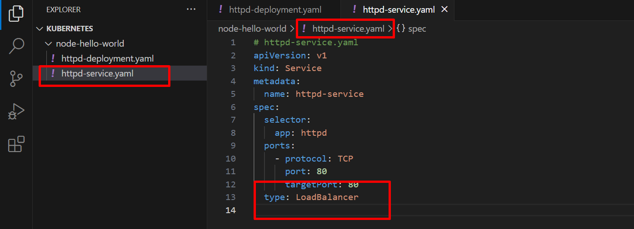

Now we successfully created httpd-service.yaml

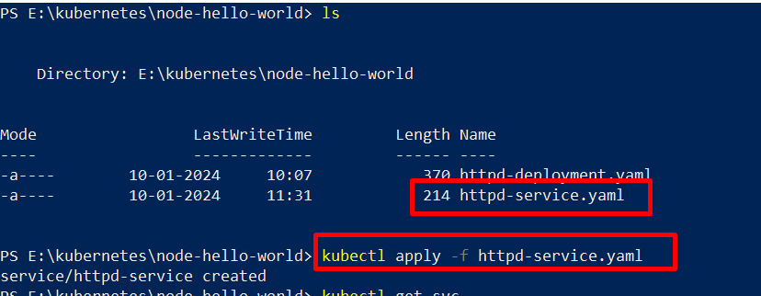

Now we check external IP was created or not.

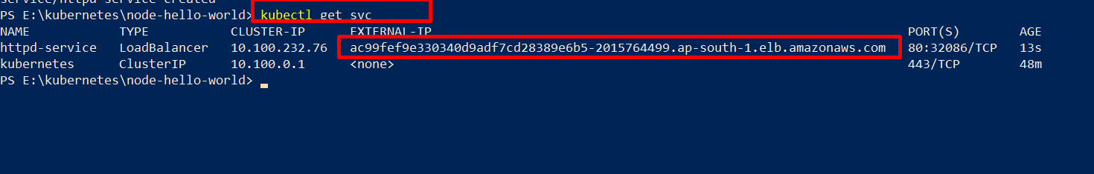

External IP successfully created now we browse that IP on Google.

That external IP is a load balancer DNS name.

On the service.yaml file we chose the load balancer type.

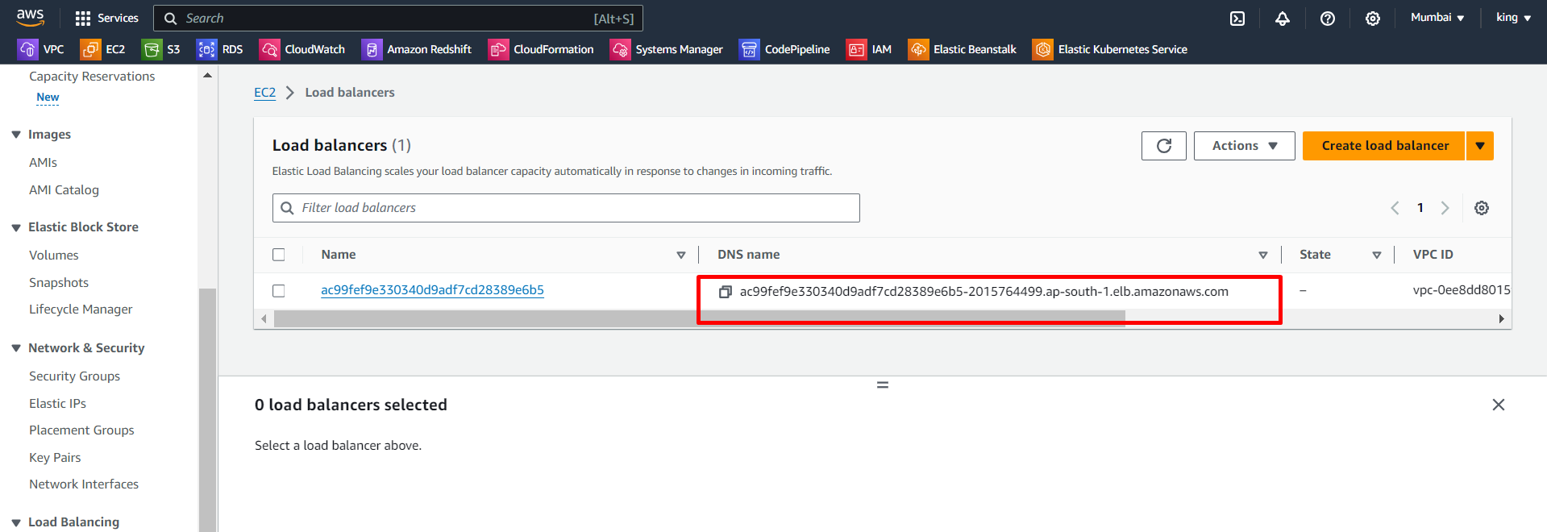

Now we copy that DNS name and browse on Google.

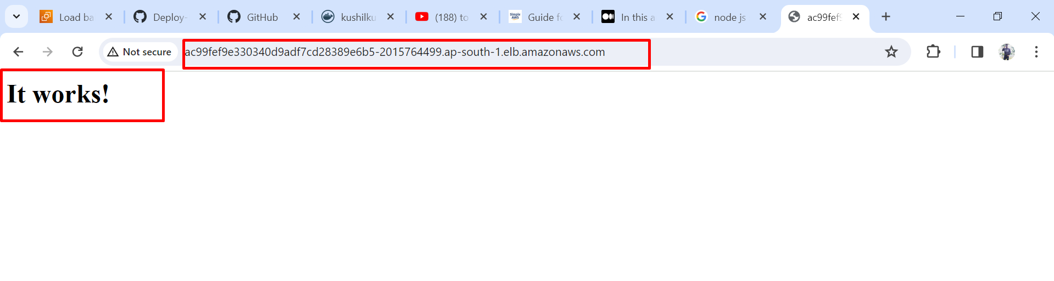

We successfully created an HTTPD pod